**Machine Drawing Practice – Final Project Report**

**S Tarun Prasad – ME17B114**

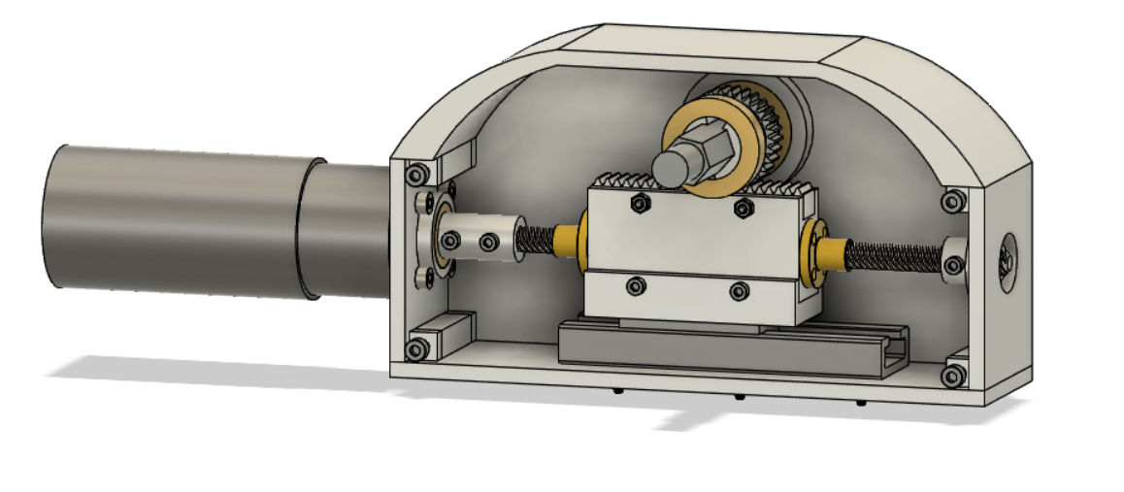

**Aim:**

To design a perpendicular high reduction self-locking transmission BlackBox.

**Theory:**

Rack and Pinion gear transmission where the pinion is coupled to the Lead Nut on the Lead Screw. The motor is coupled to the lead screw through a coupler which is mounted on the front plate via a bearing. The other end of the lead screw is supported by a bearing on the backplate. The lead nut is coupled to the part which connects to both the rack and the linear guide which can slide on the rail on the base plate. The rack meshes with the Pinion which is supported by bearings on the side plates with the help of the hexagonal shaft coupled to the pinion. When the motor powers the lead screw, it rotates and the nut translates thus moving the rack which rotates the pinion. The high reduction is achieved via the nut motion on the lead screw which also makes the transmission self-locking.

**Reduction Calculation:**

The Lead Screw used is a four-start one. Hence Lead = 4*Pitch

For every rotation of the Lead Nut and Rack move by one Lead and hence the Pinion moves by (Lead / Pitch Radius) Radians.

Hence the reduction ratio = (4*Pitch/2*Pi*Pitch Radius) = 0.08488

Torque Step-Up Ratio = 1/Reduction Ratio = 11.78097

So the output speed gets reduced to 0.08488 times of input speed while output torque gets stepped up to 11.78097 times of input torque under ideal conditions where losses are absent.